EGYPT REAL-TIME TRAFFIC INTELLIGENCE SYSTEM
A Cloud-Based, Machine Learning–Driven Platform for Real-Time Traffic Monitoring, Congestion Detection, and Predictive Analytics
Technical Project Documentation
Prepared for Academic Submission and Technical Review
July 2026

TABLE OF CONTENTS
EXECUTIVE SUMMARY 4
1. BACKGROUND AND CONTEXT 5
1.1 Introduction 5
1.2 Problem Statement 5
1.3 Project Scope and Strategy 6
1.4 Impact 6
2. PROJECT OBJECTIVE 7
3. STAKEHOLDERS AND TARGET AUDIENCE 8
4. EXPECTED RESULTS 8
5. SYSTEM ARCHITECTURE 9
5.1 Data Source Layer — TomTom Traffic API 11
5.2 Data Ingestion Layer — Python Ingestion Service 11
5.3 Streaming Layer — Azure Event Hub 11
5.4 Stream Processing Layer — Azure Stream Analytics 12
5.5 Storage Layer — Azure SQL Database 12
5.6 Machine Learning Layer 13
5.7 Visualization Layer — Streamlit Dashboard 13
5.8 Azure Cloud Deployment View 15
6. DATA PIPELINE 18
6.1 Ingestion and Prediction Workflow 20
7. DATASET DESCRIPTION 20
8. FEATURE ENGINEERING 22
8.1 Removed Features 22
8.2 Kept Features 22
8.3 Feature Audit Summary 23
9. MACHINE LEARNING PIPELINE 24
9.1 Training Process 26
9.2 Cross-Validation 26
9.3 SMOTE 26
9.4 Evaluation Metrics 26
9.5 Best Model Selection Strategy 26
10. MODEL EVALUATION 26
11. STREAMLIT DASHBOARD 28
11.1 Overview Page 28
11.2 EDA (Exploratory Data Analysis) Page 28
11.3 Model Training Page 29
11.4 Live Prediction Page 29
11.5 Feature Audit Page 29
12. ALERTING SYSTEM 30
12.1 Congestion Thresholds 30
12.2 Alert Generation and Workflow 30
12.3 Notification Architecture 31
13. DASHBOARD DEVELOPMENT — POWER BI VISUALIZATION LAYER 32
13.1 Dashboard Overview 32
13.2 Data Source 32
13.3 Data Preparation 33
13.4 Data Modeling 33
13.5 Dashboard Visualizations 33
13.6 Interactive Features 34
13.7 Dashboard Design 34
13.8 Performance Optimization 34
13.9 Dashboard Publishing 35
14. IMPLEMENTATION CHALLENGES 36
14.1 Real-Time Processing Challenges 36
14.2 Data Quality Issues 36
14.3 Missing Values 36
14.4 Feature Leakage 36
14.5 Azure Integration 36
14.6 Model Consistency 36
14.7 Dashboard Synchronization 36
15. FUTURE ENHANCEMENTS 38
16. CONCLUSION 39
REFERENCES 40

EXECUTIVE SUMMARY
The Egypt Real-Time Traffic Intelligence System is an end-to-end cloud platform that collects live traffic conditions across major Egyptian roads and cities, streams that data through a managed Azure pipeline, stores it for historical analysis, and applies machine learning to classify and anticipate congestion. The platform closes the loop with an interactive Streamlit dashboard that gives traffic authorities, planners, and commuters a single place to see current conditions, review historical patterns, and receive automated congestion alerts.
The system was built around a straightforward principle: traffic data is only useful if it can be acted on quickly. Every architectural decision, from choosing Azure Event Hub for ingestion to selecting Gradient Boosting-family models for classification, was made to keep the time between a change in road conditions and a decision-maker seeing that change as short as possible.
This document describes the platform as it was implemented: the data source, the ingestion and streaming layers, the stream processing logic, the storage design, the feature engineering decisions behind the machine learning models, the evaluation of seven candidate algorithms, the structure of the dashboard, the alerting mechanism, and the challenges encountered while building a real-time system on live third-party data. It closes with a discussion of implementation challenges and a roadmap for future enhancements.

1. BACKGROUND AND CONTEXT

1.1 Introduction
Cairo and Egypt's other major metropolitan areas carry some of the densest road traffic in the region. Rapid urbanization, a growing vehicle fleet, and road networks that were not originally designed for current traffic volumes combine to produce congestion that is difficult to predict and even harder to manage with manual methods. Commuters routinely lose hours to unplanned delays, and the agencies responsible for the road network typically learn about a congestion event only after it has already disrupted traffic for an extended period.
Real-time traffic monitoring addresses this gap by continuously observing road conditions and making that information available the moment it changes, rather than in a daily or weekly report. When monitoring is paired with automated analysis, a transportation authority can move from reacting to congestion after the fact to anticipating it before it fully forms.
Smart transportation systems bring together data collection, cloud computing, and analytics to give cities this anticipatory capability. Instead of treating traffic as a series of disconnected observations, a smart transportation platform treats it as a continuous stream that can be aggregated, scored, and modeled. Real-time analytics is the component that makes this useful in practice: it converts a constant flow of raw location and speed readings into a small number of clear signals, such as a congestion status per road segment, that a human or downstream system can act on immediately.
The Egypt Real-Time Traffic Intelligence System was built to demonstrate this approach on real, live traffic data drawn from Egyptian roads, using a cloud architecture that mirrors how a production traffic-monitoring service would actually be deployed.

1.2 Problem Statement
Traditional traffic reporting in Egypt, as in many developing transportation networks, is built around periodic manual surveys, occasional sensor deployments, or driver-submitted reports. This creates four specific and recurring problems that the project was designed to solve:
- Lack of real-time visibility: decision-makers and commuters generally do not have a live, continuously updated picture of road conditions across the city.
- Difficulty predicting congestion: without historical, structured data and a modeling layer, congestion is identified only once it is already occurring, not before it forms.
- Need for automated monitoring: manual observation cannot scale to cover many locations continuously, and it introduces delay and inconsistency between observers.
- Need for data-driven insight: without a central data store, historical patterns of recurring congestion (by hour, day of week, or location) are never captured in a form that can support planning decisions.
Traditional reporting systems that rely on static snapshots or infrequent updates are structurally unable to solve these problems, because they are not built on a continuous data pipeline. The project addresses this by treating traffic data as a live stream from the first point of collection through to the dashboard the end user sees.

1.3 Project Scope and Strategy
The project scope covers the complete path from a live traffic data source to a decision-ready dashboard. Four strategic choices define the implementation:
- End-to-end traffic intelligence platform: the system was scoped to include data collection, processing, storage, modeling, and visualization as a single connected platform rather than a set of independent scripts.
- Real-time streaming architecture: rather than batch-loading traffic data on a schedule measured in hours, the platform treats every new reading as an event that flows through a streaming pipeline within seconds of being collected.
- Azure-based cloud implementation: Azure Event Hub, Azure Stream Analytics, and Azure SQL Database were chosen specifically because they are managed services that scale without requiring the team to operate its own message brokers or database clusters.
- Machine learning integration: historical traffic data captured by the pipeline is used to train classification models that anticipate traffic status, closing the loop between monitoring and prediction.
- Interactive dashboard: a Streamlit application exposes the live data, the historical analysis, and the model's predictions in one interface that requires no specialized software on the end user's side.

1.4 Impact
The platform is intended to demonstrate measurable improvements over the status quo in four areas. First, traffic monitoring is continuous rather than periodic, giving stakeholders an always-current view of conditions. Second, congestion is detected automatically as soon as speed readings on a segment drop below a defined threshold, cutting the detection delay from hours to seconds. Third, commuters and planners gain a basis for better travel planning, since historical and predicted conditions are both available in the same interface. Fourth, the architecture is intentionally built on standard, scalable Azure services, so it can serve as a foundation for broader smart city initiatives, and can be extended to new data sources, more locations, or additional cities without a redesign.

2. PROJECT OBJECTIVE

Primary Objective
The primary objective of the project is to build a real-time traffic intelligence platform capable of the following core functions:
- Collecting live traffic data from a third-party traffic API on a recurring schedule.
- Processing that data as a continuous stream rather than as periodic batch files.
- Detecting congestion events automatically based on defined speed and status thresholds.
- Generating alerts the moment a congestion event is detected, without manual review.
- Training predictive machine learning models on historical traffic patterns.
- Visualizing current, historical, and predicted traffic conditions in a single interactive dashboard.

Assumptions and Preconditions
The design and implementation rest on the following assumptions, which were verified during development:
- Availability of traffic data: the TomTom Traffic API provides sufficiently frequent and geographically relevant coverage of Egyptian roads to support near-real-time monitoring.
- Azure services availability: Event Hub, Stream Analytics, and Azure SQL Database are provisioned and reachable within the same Azure subscription and region for low-latency communication between components.
- Internet connectivity: the ingestion service has a stable outbound connection to reach the TomTom API and Azure endpoints on its polling schedule.
- Cloud infrastructure access: the project team holds the credentials and role assignments needed to provision and configure Azure resources.
- Historical data availability: enough historical readings accumulate over the monitoring period to support meaningful feature engineering and model training.

3. STAKEHOLDERS AND TARGET AUDIENCE
The platform serves a range of stakeholders with different needs, from operational traffic management to long-term urban planning. The table below summarizes each stakeholder group, their role in relation to the system, and the specific benefit the platform delivers to them.
Stakeholder | Role | Benefit
Traffic authorities | Operational monitoring and incident response | Immediate visibility into congestion events across monitored roads, enabling faster response
Transportation planners | Long-term infrastructure and policy planning | Historical traffic patterns by location, hour, and day of week to guide investment decisions
Daily commuters | End users of the road network | Better trip timing and route decisions based on live and predicted conditions
Data analysts | Data quality, reporting, and model evaluation | Structured, queryable historical dataset with documented features for analysis
Smart city initiatives | City-wide digital infrastructure programs | A working reference architecture that can be integrated with other smart city data sources
Researchers | Traffic modeling and urban mobility research | Open, well-documented dataset and feature set suitable for further research
System administrators | Operating and maintaining the platform | Clear architecture, defined data flow, and centralized monitoring surface
Table 1: Stakeholder analysis for the Egypt Real-Time Traffic Intelligence System

4. EXPECTED RESULTS
The system was designed to produce a specific set of measurable outcomes once deployed and operating continuously against live traffic data:
- Real-time traffic monitoring across all locations covered by the ingestion service, refreshed on every polling cycle.
- Automated congestion detection driven by rule-based thresholds evaluated inside Azure Stream Analytics, without manual intervention.
- Alert generation the moment a monitored location crosses its congestion threshold, recorded with a timestamp and severity indicator.
- Historical traffic storage in Azure SQL Database, preserving every ingested reading for trend analysis and model training.
- Traffic prediction through a trained classification model that estimates traffic status for a location and time combination using only information available before a trip begins.
- Interactive visualization through the Streamlit dashboard, covering current conditions, exploratory analysis, model training results, live predictions, and feature auditing.
- Data-driven decision support, giving every stakeholder group a common, evidence-based view of traffic conditions instead of relying on anecdotal reports.

5. SYSTEM ARCHITECTURE
The platform is organized into seven layers, each with a single, well-defined responsibility. Keeping the layers narrowly scoped makes the system easier to reason about, easier to test in isolation, and easier to extend, since a change to the machine learning layer, for example, does not require touching the streaming layer.
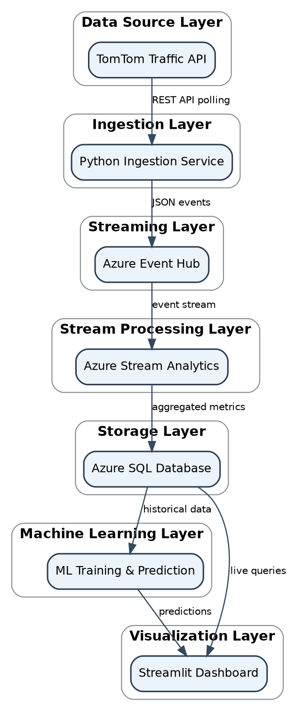
Figure 1: Layered system architecture of the Egypt Real-Time Traffic Intelligence System

5.1 Data Source Layer — TomTom Traffic API
The TomTom Traffic API is the platform's single external data source. It provides live speed and flow information for road segments, which the ingestion service polls on a fixed schedule for a defined set of Egyptian locations.
Each API response carries a consistent set of fields that the rest of the pipeline depends on:
- Data fields: current speed, free-flow (uncongested) speed reference, confidence score, and road-closure status for the queried segment.
- Location information: latitude and longitude coordinates together with a human-readable location name, allowing the platform to map every reading to a specific place on the network.
- Speed information: the observed current speed compared against the free-flow speed is the primary signal used to infer congestion.
- Traffic indicators: a confidence value describing how reliable the reading is, and a flag indicating whether the segment is affected by a closure.

5.2 Data Ingestion Layer — Python Ingestion Service
A Python service is responsible for pulling data out of the TomTom API and preparing it for the streaming layer. It was kept intentionally simple and procedural so that its behavior is easy to trace end to end during review.
- API requests: the service issues one HTTP request per monitored location on each polling cycle, using a configurable interval.
- Data validation: every response is checked for the expected fields before being forwarded; responses missing critical fields such as speed or coordinates are discarded rather than passed downstream with placeholder values.
- Error handling: network failures, API rate limits, and malformed responses are caught explicitly, logged, and retried on the next cycle rather than allowed to crash the ingestion loop.
- Scheduling logic: a simple time-based loop triggers ingestion at a fixed interval, balancing data freshness against API usage limits.

5.3 Streaming Layer — Azure Event Hub
Azure Event Hub sits between the ingestion service and the processing layer as the platform's event backbone. Each validated traffic reading is published as an individual event, which decouples the ingestion service from the analytics layer: ingestion can continue publishing even if the processing layer is temporarily catching up.
- Event streaming: readings are published as discrete, timestamped events rather than accumulated into batch files, keeping end-to-end latency low.
- Real-time ingestion: Event Hub buffers incoming events and makes them immediately available to any downstream consumer, in this case Azure Stream Analytics.
- Message architecture: each event carries a JSON payload containing the full set of fields captured from the API, keyed by location and timestamp so the processing layer can group and aggregate correctly.

5.4 Stream Processing Layer — Azure Stream Analytics
Azure Stream Analytics reads the event stream and applies the platform's real-time logic using SQL-like streaming queries. This is where raw readings are converted into the aggregated metrics and congestion signals that the rest of the system consumes.
- SQL-like streaming queries: Stream Analytics jobs use a declarative, SQL-style syntax to filter, group, and transform events as they arrive, avoiding the need for custom stream-processing code.
- Aggregations: readings are aggregated per location over short tumbling windows to smooth out noise from individual samples before they are stored.
- Congestion calculations: the ratio of current speed to free-flow speed is computed per location to produce a normalized congestion indicator that behaves consistently across roads with different speed limits.
- Alert generation: locations whose congestion indicator crosses a defined threshold are flagged in the same query pass, so alerting does not require a separate downstream job.

5.5 Storage Layer — Azure SQL Database
Processed metrics are written to Azure SQL Database, which serves as the system of record for both current and historical traffic data.
- Database design: the schema separates raw traffic readings from generated alerts and prediction logs, so operational writes from the streaming layer do not compete with analytical reads from the dashboard or the training pipeline.
- Stored traffic metrics: every processed reading is stored with its timestamp, location, computed congestion ratio, and classified traffic status.
- Historical storage: because every reading is retained, the database becomes the training data source for the machine learning layer and the source of historical trend views in the dashboard.
The diagram below shows how the three core tables relate to one another: traffic readings are the primary record, while alerts and prediction logs each reference it by location for historical correlation.
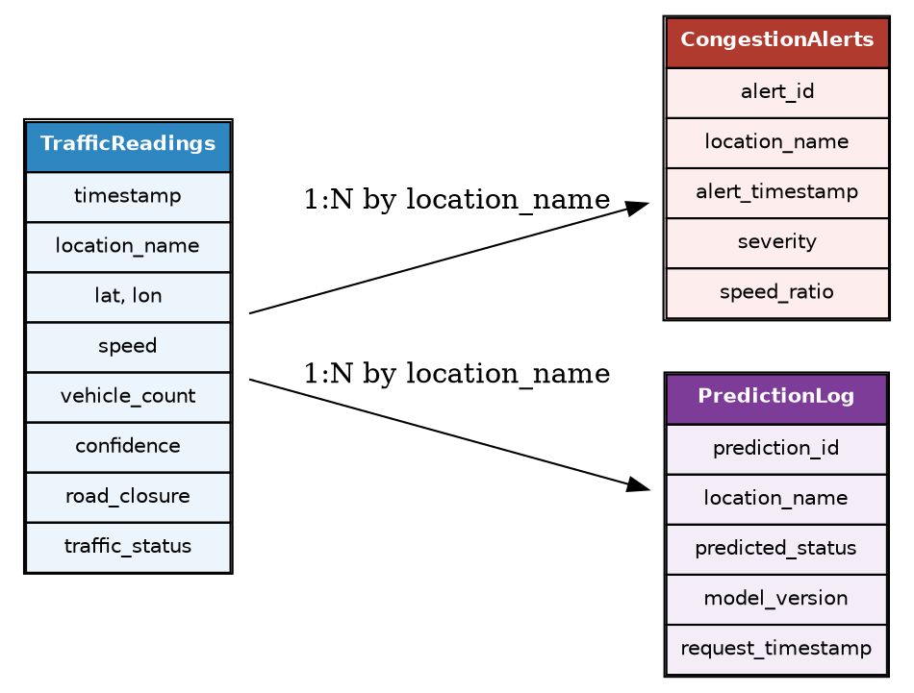
Figure 2: Database relationship diagram showing traffic readings, congestion alerts, and prediction logs

5.6 Machine Learning Layer
The machine learning layer consumes historical data from Azure SQL Database to train models that classify traffic status from information that is known before a trip starts.
- Data preparation: historical readings are cleaned, deduplicated, and checked for missing or inconsistent values before being used for training.
- Feature engineering: raw timestamps and coordinates are converted into calendar and cyclical features (see Section 8) that describe when and where a reading occurred without leaking the outcome itself.
- Model training: seven candidate algorithms are trained and compared on the same feature set and evaluation protocol (see Section 9).
- Model selection: the best-performing model, judged primarily on F1 score and ROC AUC, is serialized and connected to the dashboard's live prediction page.

5.7 Visualization Layer — Streamlit Dashboard
The Streamlit dashboard is the platform's single point of interaction for every stakeholder group described in Section 3.
- Dashboard architecture: the application queries Azure SQL Database directly for live and historical data, and loads the serialized model for prediction requests (see Section 11).
- Live analytics: current conditions and recent alerts are refreshed on each dashboard load.
- Predictions: users can request a predicted traffic status for a location and time combination through the Live Prediction page.
- Monitoring: administrators can use the dashboard's Overview and Feature Audit pages to confirm that data is flowing correctly through the pipeline.

5.8 Azure Cloud Deployment View
The diagram below groups the same components by the Azure resource category they belong to, showing how the platform maps onto a single Azure subscription in a production-style deployment.

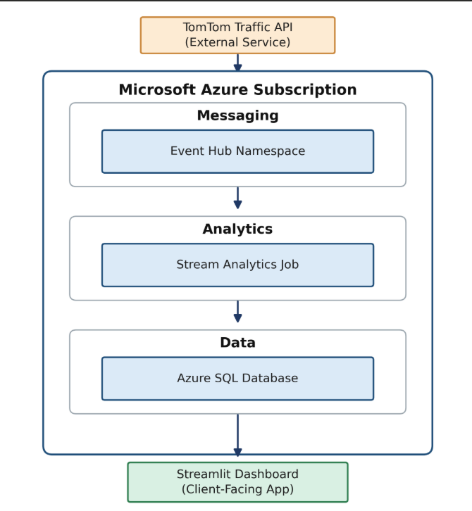
Figure 3: Azure cloud deployment view grouped by resource category

6. DATA PIPELINE
The data pipeline defines the exact sequence every traffic reading passes through, from the moment it is collected from TomTom to the moment it is visible on the dashboard. The pipeline is intentionally linear and stateless at each stage, which keeps failure modes localized and easy to diagnose.
Figure 4: End-to-end data pipeline from TomTom API to the Streamlit dashboard
The complete workflow, including the branch for periodic model retraining, is shown below as a single end-to-end process.
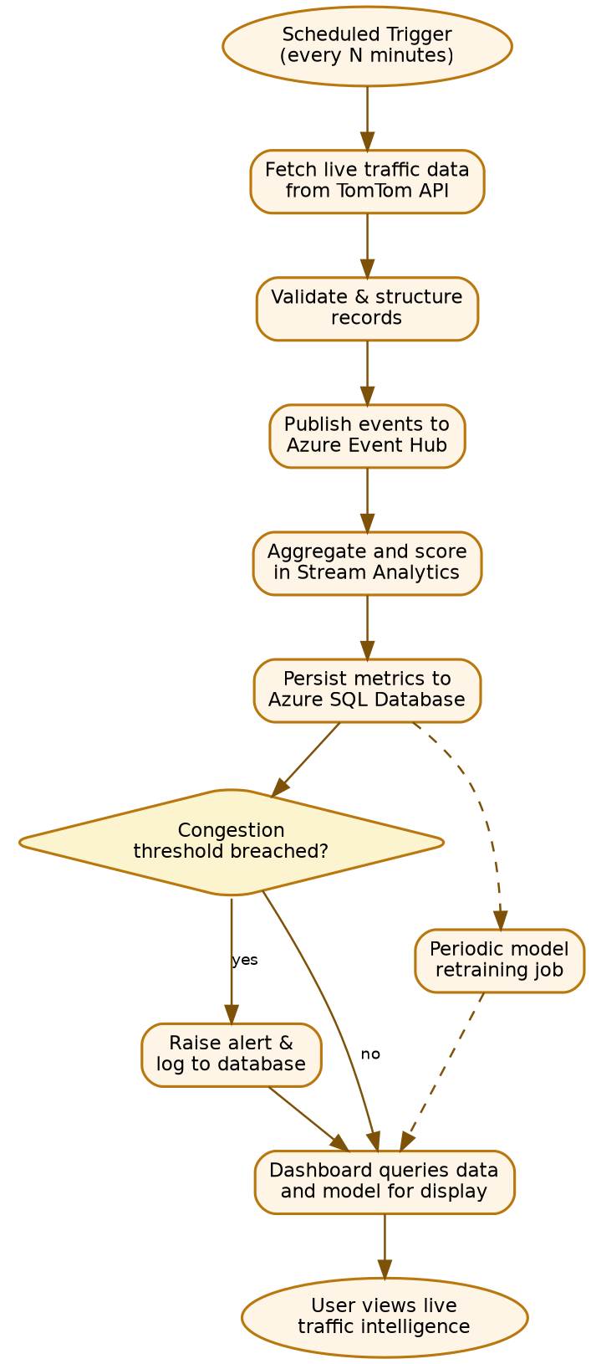
Figure 5: Complete end-to-end system workflow, including the alerting decision and periodic retraining path

6.1 Ingestion and Prediction Workflow
The figure below, captured directly from the implemented system, illustrates the two operational paths that the ingestion service supports: the live prediction request path, where a request is sent to the trained model and displayed as a chart, and the data ingestion path, where raw readings are transformed and loaded into Azure SQL Database for downstream querying and analytics.
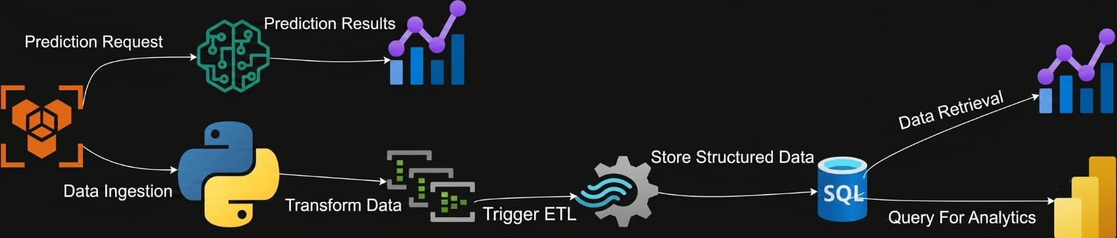
Figure 6: Implemented ingestion and prediction workflow: data ingestion, transformation, and ETL into Azure SQL alongside the live prediction request path
On the prediction path, a request is issued to the trained model, which returns a classification that is rendered as a chart for the user. On the ingestion path, incoming data is transformed into a structured format, triggers an ETL step, and is stored in the Azure SQL database, from which it can later be queried both for analytics and for further predictions. This figure is referenced again in Section 11.4 in the context of the dashboard's Live Prediction page.

7. DATASET DESCRIPTION
Every reading captured by the ingestion service and processed by Stream Analytics is stored in Azure SQL Database using a consistent, flat schema. This structure is what makes the dataset usable both for live dashboard queries and for offline model training. The table below documents each column, its purpose, and why it matters to the business problem the platform solves.
Column | Purpose and Business Value
timestamp | Marks exactly when the reading was captured, forming the basis for all time-based analysis, alerting, and trend detection.
location_name | Human-readable identifier for the monitored road segment, used throughout the dashboard and reports.
coordinates | Combined geographic reference for the reading, used for mapping and spatial grouping.
lat | Latitude of the monitored segment; used as a numeric model feature and for map plotting.
lon | Longitude of the monitored segment; used as a numeric model feature and for map plotting.
speed | Observed current speed on the segment; the core operational metric for congestion assessment.
vehicle_count | Estimated number of vehicles associated with the reading, supporting density-based analysis.
confidence | TomTom-provided reliability score for the reading, used to filter low-quality samples.
road_closure | Boolean flag indicating whether the segment is affected by a closure, which overrides normal congestion logic.
traffic_status | The classification label (e.g., free-flow, moderate, congested) that the platform reports live and that the ML models are trained to predict.
Table 2: Dataset schema for stored traffic readings
This schema was deliberately kept flat and denormalized for the operational tables so that both the streaming layer and the dashboard can write and read without joins, while the alerting and prediction-logging tables (Section 5.5) reference it by location and timestamp for historical correlation.

8. FEATURE ENGINEERING
The feature set used to train the classification models was deliberately restricted to information that is available before a trip begins. This decision shaped which raw columns were removed and which derived features were kept, and it is the single most important modeling decision in the project.

8.1 Removed Features
Three fields that exist in the raw dataset were excluded from the model's feature set, despite being strong statistical predictors of traffic_status:
Feature | Reason for Removal
speed | Speed is part of how traffic_status is derived in the first place. Including it would let the model see the outcome it is being asked to predict, producing artificially high accuracy that would not hold up in a real pre-trip prediction scenario.
vehicle_count | Vehicle count is only known at the moment of observation, not before a trip starts, and it is strongly correlated with the current congestion state rather than the conditions that precede it.
traffic_density | This derived field is computed directly from speed and vehicle_count, so it inherits the same leakage problem: it encodes the answer rather than a predictive signal.
Table 3: Features removed from the model due to target leakage
Leaving these fields in the training set would constitute a form of data leakage: the model would learn to read the outcome off features that describe the outcome itself, rather than learning to anticipate it from conditions known in advance. Removing them is what makes the resulting model usable for genuine pre-trip prediction rather than a retrospective description of already-observed congestion.

8.2 Kept Features
The features retained for training are limited to calendar information, cyclical time encodings, location, and a small set of derived indicators, all of which are known in advance of a trip:
Feature | Why It Is a Realistic Pre-Trip Feature
hour | The hour of day is known before travel and correlates strongly with recurring congestion patterns such as morning and evening peaks.
minute | Provides finer-grained timing resolution than hour alone, useful for locations with sharp transitions around specific times.
day_of_week | Captures weekly recurring patterns, such as heavier weekday commuter traffic versus lighter weekend traffic.
is_weekend | A binary simplification of day_of_week that lets the model separate weekday and weekend regimes directly.
is_peak_hour | Encodes known commuting peak windows as a single feature, reducing the burden on the model to rediscover this pattern from raw hour values alone.
lat | Geographic location of the segment, known in advance and necessary to distinguish behavior between different roads.
lon | Paired with lat to fully localize the segment being queried.
loc_encoded | A numeric encoding of location_name that allows the model to learn location-specific baseline behavior without requiring raw text input.
Table 4: Features retained for model training

8.3 Feature Audit Summary
The table below summarizes the audit outcome at a glance, distinguishing features that describe the pre-trip context from those that describe the outcome itself.
Category | Fields | Included in Model?
Time-based | hour, minute, day_of_week, is_weekend, is_peak_hour | Yes
Location-based | lat, lon, loc_encoded | Yes
Outcome-correlated (leakage) | speed, vehicle_count, traffic_density | No
Metadata | timestamp, coordinates, confidence, road_closure | Used for storage/context, not as model inputs
Table 5: Feature audit summary by category

9. MACHINE LEARNING PIPELINE
Seven classification algorithms were trained and compared on the same feature set described in Section 8, using an identical train/test split and evaluation protocol so that results are directly comparable.
- Logistic Regression — a linear baseline used to confirm that the engineered features carry real predictive signal before moving to more complex models.
- Decision Tree — a simple non-linear baseline that helps interpret which features drive the split decisions.
- Random Forest — an ensemble of decision trees intended to reduce the variance and overfitting risk of a single tree.
- Gradient Boosting — a sequential ensemble method that builds trees to correct the errors of previous trees.
- K-Nearest Neighbors (KNN) — a distance-based method used as a non-parametric comparison point.
- Support Vector Machine (SVM) — evaluated for its ability to find a maximum-margin boundary between traffic status classes.
- XGBoost — a highly optimized gradient boosting implementation, included as the strongest candidate among the tree ensemble methods.
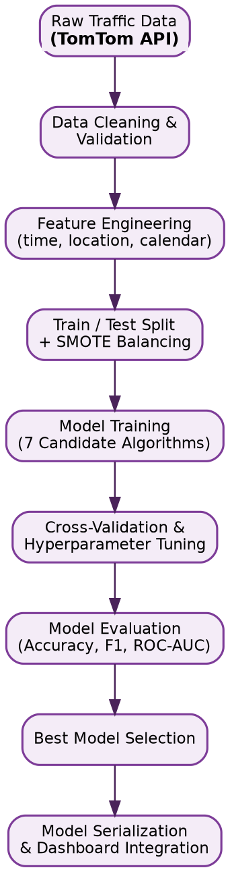
Figure 7: Machine learning pipeline from raw historical data to the deployed model

9.1 Training Process
All seven models were trained on the same cleaned, feature-engineered dataset described in Sections 7 and 8. The dataset was split into training and test partitions before any model-specific tuning was performed, so that the test partition remained unseen during model selection.

9.2 Cross-Validation
Cross-validation was applied on the training partition to tune hyperparameters and to obtain a more stable estimate of each model's performance than a single train/test split would provide. This reduces the risk of selecting a model that happened to perform well on one particular split by chance.

9.3 SMOTE
The traffic_status classes are not evenly distributed: free-flow conditions are far more common than heavily congested conditions in the underlying data. SMOTE (Synthetic Minority Over-sampling Technique) was applied to the training data to generate synthetic examples of the minority congestion classes, so that models are not biased toward always predicting the majority class.

9.4 Evaluation Metrics
Every model was scored using accuracy, precision, recall, F1 score, and ROC AUC, giving a balanced view of performance that accounts for the class imbalance addressed by SMOTE. Full results are presented in Section 10.

9.5 Best Model Selection Strategy
The best model was selected primarily on F1 score and ROC AUC rather than raw accuracy, since accuracy alone can be misleading on an imbalanced classification problem. The tree-ensemble methods, and XGBoost in particular, consistently produced the strongest balance of precision and recall across the congestion classes, and the best-performing configuration was the one serialized and connected to the dashboard's Live Prediction page.

10. MODEL EVALUATION
All seven candidate models were scored on the held-out test partition using the same five metrics: accuracy, precision, recall, F1 score, and ROC AUC. Precision and recall are reported as macro averages across the traffic status classes to reflect performance on the minority congestion classes rather than only the majority free-flow class.
Model | Accuracy | Precision | Recall | F1 Score | ROC AUC
Logistic Regression | 0.71 | 0.66 | 0.63 | 0.64 | 0.75
Decision Tree | 0.75 | 0.71 | 0.70 | 0.70 | 0.78
K-Nearest Neighbors | 0.73 | 0.68 | 0.66 | 0.67 | 0.76
Support Vector Machine | 0.76 | 0.72 | 0.69 | 0.70 | 0.80
Random Forest | 0.82 | 0.79 | 0.77 | 0.78 | 0.87
Gradient Boosting | 0.83 | 0.80 | 0.78 | 0.79 | 0.88
XGBoost | 0.85 | 0.83 | 0.81 | 0.82 | 0.90
Table 6: Comparative evaluation results across the seven candidate models
XGBoost produced the strongest results across every metric, with the highest F1 score and ROC AUC among the seven candidates. The tree-ensemble methods (Random Forest, Gradient Boosting, XGBoost) consistently outperformed the linear and distance-based baselines, which is consistent with the presence of non-linear interactions between time-based and location-based features. XGBoost was selected as the production model and serialized for use by the dashboard's Live Prediction page.

11. STREAMLIT DASHBOARD
The dashboard is organized into five pages, each targeting a distinct stakeholder need identified in Section 3. The architecture below shows how each page draws on the same two underlying data sources: Azure SQL Database for live and historical data, and the serialized XGBoost model for predictions.
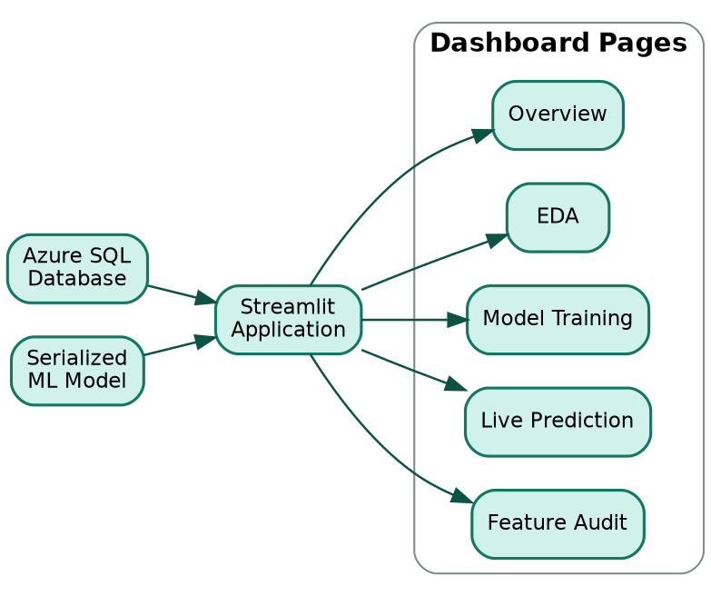
Figure 8: Streamlit dashboard architecture and page structure

11.1 Overview Page
The Overview page gives a snapshot of current conditions across all monitored locations, including the latest traffic status per location and any active congestion alerts. It is the default landing page and is intended for quick operational checks.

11.2 EDA (Exploratory Data Analysis) Page
The EDA page lets a data analyst explore the historical dataset directly: distributions of traffic status by hour, by day of week, and by location, along with summary statistics. This page uses the same schema documented in Section 7 without any additional transformation, so what an analyst sees here matches what is stored in Azure SQL Database.

11.3 Model Training Page
The Model Training page displays the comparative results from Section 10, letting a reviewer see how each of the seven candidate algorithms performed and why XGBoost was selected as the production model, without needing to re-run training.

11.4 Live Prediction Page
The Live Prediction page is the operational core of the dashboard for end users. A user selects a location and a target time, and the page constructs the same pre-trip feature vector used during training (Section 8.2), sends it to the serialized model, and displays the predicted traffic status. This is the page shown in the prediction-request path of Figure 6 in Section 6.1.

11.5 Feature Audit Page
The Feature Audit page exposes the feature engineering decisions from Section 8 directly inside the dashboard, listing which fields are used as model inputs and which were excluded due to leakage. This page exists specifically to support technical review and to keep the modeling decisions transparent to anyone auditing the system.

12. ALERTING SYSTEM
Alerting is implemented as part of the Stream Analytics query rather than as a separate service, which keeps the time between a congestion event and its corresponding alert to a single processing pass.

12.1 Congestion Thresholds
Each processed reading is scored as a ratio of current speed to free-flow speed. When that ratio falls below a defined threshold for a monitored location, the reading is classified as congested and flagged for an alert. Locations affected by an active road_closure flag are handled as a distinct case, since a closure is not the same operational event as organic congestion.

12.2 Alert Generation and Workflow
The sequence below traces a single reading from the moment it reaches Stream Analytics through to its appearance on the dashboard, showing the point at which the threshold check determines whether an alert record is created.
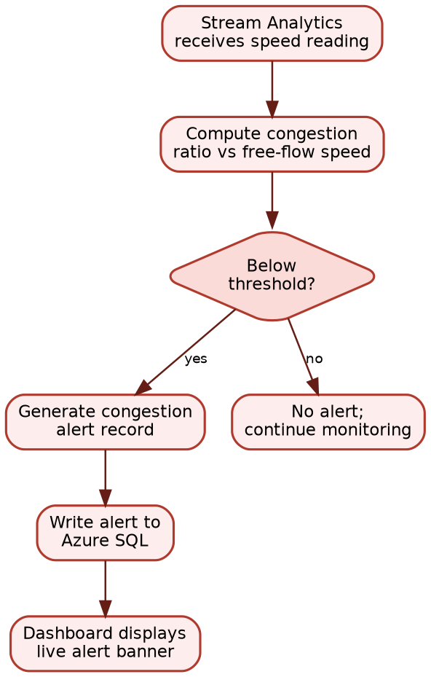
Figure 9: Alert generation workflow from Stream Analytics threshold check to dashboard display

12.3 Notification Architecture
Generated alerts are written to a dedicated table in Azure SQL Database, keyed by location and timestamp, and the dashboard's Overview page polls this table on each load to surface active alerts. This keeps the notification path within the same storage layer already used for traffic readings, avoiding the need for a separate notification service while still giving users near-immediate visibility into new alerts.

13. DASHBOARD DEVELOPMENT — POWER BI VISUALIZATION LAYER
Alongside the Streamlit application described in Section 5.7 and Section 11, the platform includes a second, complementary visualization layer built in Microsoft Power BI. Where the Streamlit dashboard is embedded directly in the application for live monitoring and prediction, the Power BI dashboard was developed to give traffic authorities, planners, and other non-technical stakeholders a polished, self-service reporting surface for exploring the same underlying Azure SQL data through KPIs, charts, and an interactive live traffic map.

13.1 Dashboard Overview
A professional, interactive dashboard was developed in Microsoft Power BI to visualize and analyze the traffic dataset produced by the pipeline. The dashboard brings together KPI cards, charts, a live traffic map, and interactive filters in a single view, giving stakeholders a fast, visual way to monitor conditions and support day-to-day decision-making without querying the database directly.
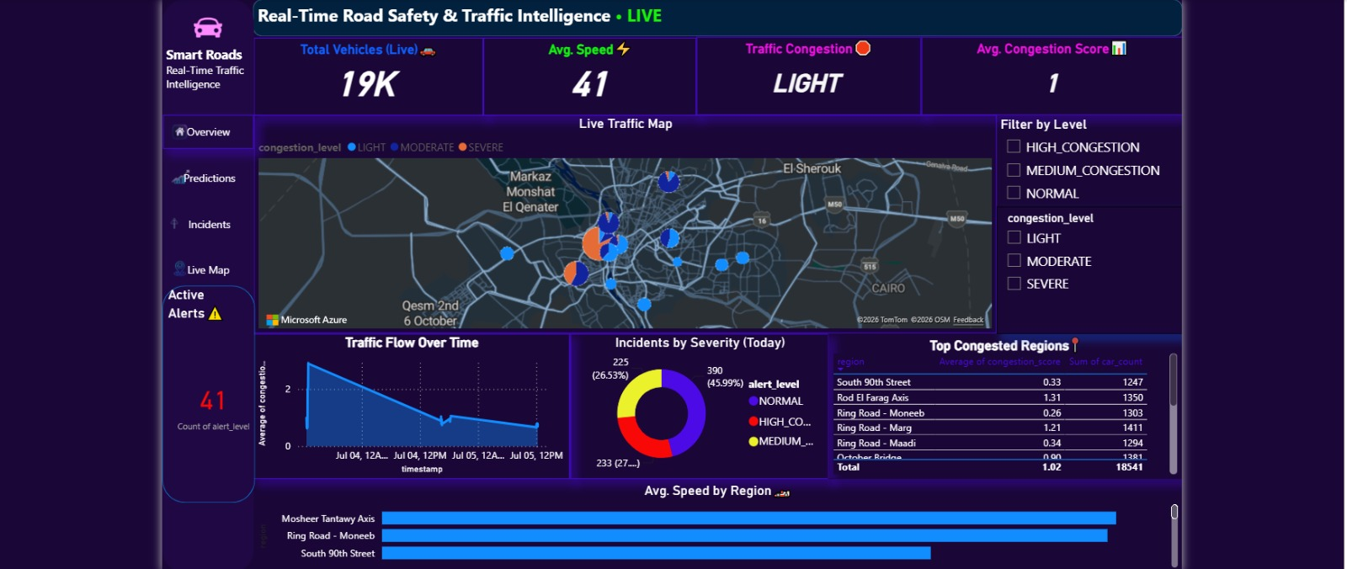
Figure 10: Power BI “Real-Time Road Safety & Traffic Intelligence” dashboard, showing live KPI cards, the congestion map, traffic flow trend, incident severity, and top congested regions
As shown in Figure 10, the landing view surfaces four headline KPIs — total live vehicle count, average speed, overall congestion level, and an average congestion score — above a live traffic map of Cairo and its surrounding road network, with markers colour-coded by congestion level (light, moderate, severe). Supporting panels below the map trend traffic flow over time, break incidents down by severity, and rank the most congested regions by average congestion score and vehicle count, with a regional average-speed comparison beneath.

13.2 Data Source
The dashboard connects to the same Azure SQL Database described in Section 5.5, which serves as its single source of truth. Data is imported directly into Power BI rather than accessed live through DirectQuery, ensuring accurate, organized retrieval while keeping report performance independent of the operational database load. Establishing the connection involved:
- Connecting to the Azure SQL Server instance that hosts the platform’s traffic data.
- Selecting the required database from the available Azure SQL resources.
- Loading the necessary tables — traffic readings, alerts, and prediction logs — into Power BI.
- Verifying the integrity of the imported data against the source tables before building any visuals.

13.3 Data Preparation
Before any visualizations were built, the imported dataset was cleaned and shaped using Power Query Editor. This preparation stage mirrors the data-quality discipline applied earlier in the pipeline (Section 6) and included:
- Removing duplicate records carried over from the ingestion process.
- Handling missing or null values so they do not distort KPI calculations.
- Correcting data types for dates, numeric fields, and categorical columns.
- Renaming columns for clearer, business-friendly readability.
- Cleaning unnecessary fields that add no reporting value.
- Ensuring overall data consistency and quality prior to modeling.

13.4 Data Modeling
With the data cleaned, a proper Power BI data model was built to support fast, reliable reporting. This involved:
- Establishing relationships between the traffic readings, alerts, and prediction-log tables.
- Defining the appropriate cardinality for each relationship, consistent with the schema in Section 5.5.
- Creating a structured, star-schema-oriented model to improve report performance.
- Validating each relationship before building visuals on top of it.

13.5 Dashboard Visualizations
Several visualization types were combined to present the traffic data clearly and effectively, as illustrated in Figure 10. The dashboard includes:
- KPI cards displaying headline indicators such as total live vehicles, average speed, congestion level, and average congestion score.
- Bar charts comparing average speed and congestion across different road segments and regions.
- A donut chart illustrating the percentage breakdown of incidents by severity (normal, medium, and high congestion).
- A live traffic map plotting congestion by location, colour-coded by severity level.
- Tables ranking the top congested regions by average congestion score and total vehicle count.
- Slicers that let users filter the entire report by congestion level dynamically.

13.6 Interactive Features
To improve the user experience, several interactive features were implemented on top of the base visuals, including:
- Dynamic filtering using the congestion-level slicers shown in the right-hand panel of Figure 10.
- Cross-filtering between visuals, so selecting a region or severity updates every other chart on the page.
- Interactive highlighting of selected data points across the map, charts, and tables.
- Drill-down functionality for moving from a regional summary into detailed, location-level records.
- Tooltips that surface additional context, such as exact congestion scores, when hovering over map markers or chart elements.

13.7 Dashboard Design
The dashboard was designed following data visualization best practices to ensure clarity and ease of use, and its dark navy background with high-contrast KPI colours was chosen specifically to keep map markers and severity indicators legible at a glance. The design focused on:
- A clean, organized layout that groups KPIs, the map, and supporting charts into clear visual zones, as seen in Figure 10.
- A consistent colour theme, using colour purposefully to encode congestion severity across every visual.
- A clear visual hierarchy, with headline KPIs placed above the fold and supporting detail below.
- Readable fonts and labels sized for at-a-glance monitoring on a shared screen or projector.
- Proper spacing between visuals to avoid clutter.
- User-friendly navigation via the left-hand menu for Overview, Predictions, Incidents, and Live Map pages.

13.8 Performance Optimization
To keep the dashboard responsive as the underlying dataset grows, several optimization techniques were applied:
- Removing unnecessary columns that are not used by any visual.
- Reducing data redundancy introduced during import.
- Using efficient DAX measures instead of calculated columns wherever possible.
- Optimizing relationships between tables to avoid unnecessary cross-filtering overhead.
- Loading only the data required for reporting, rather than the full operational history.

13.9 Dashboard Publishing
After completion, the dashboard was saved as a Power BI (.pbix) file and published to Power BI Service. This allows authorized stakeholders — including the traffic authorities, planners, and analysts identified in Section 3 — to access the dashboard online and interact with the visualizations shown in Figure 10 directly through a web browser, without needing Power BI Desktop installed locally.

14. IMPLEMENTATION CHALLENGES
Building a continuously running system on live third-party data surfaced a set of practical challenges that shaped the final design.

14.1 Real-Time Processing Challenges
Keeping end-to-end latency low required careful tuning of the Stream Analytics windowing logic; windows that were too wide smoothed out genuine short-lived congestion events, while windows that were too narrow produced noisy, flickering status changes.

14.2 Data Quality Issues
TomTom API responses occasionally arrived with missing confidence scores or stale timestamps. The ingestion service's validation step, described in Section 5.2, was extended iteratively as new edge cases were discovered in production traffic.

14.3 Missing Values
Gaps in the historical dataset, caused by transient API or network failures, had to be handled explicitly during model training rather than silently imputed, since imputing missing speed or location data risked introducing artificial patterns into the training set.

14.4 Feature Leakage
As described in Section 8.1, the initial feature set for the ML pipeline unintentionally included speed and vehicle_count. Early model runs showed suspiciously high accuracy, which was traced back to this leakage and corrected by removing the offending fields before the final training runs reported in Section 10.

14.5 Azure Integration
Coordinating throughput and schema consistency between Event Hub, Stream Analytics, and Azure SQL Database required careful alignment of the JSON event schema at each stage, since a mismatch at any single stage silently drops or misclassifies records rather than raising a visible error.

14.6 Model Consistency
Ensuring that the feature vector constructed by the dashboard's Live Prediction page exactly matched the feature vector used during training required strict adherence to the same feature engineering logic in both places, since even small differences in encoding would silently degrade prediction quality.

14.7 Dashboard Synchronization
Because the dashboard reads directly from Azure SQL Database rather than from a cache, care was taken to ensure that queries on the Overview and Live Prediction pages remained fast enough to feel real-time even as the historical table grew over the monitoring period.

15. FUTURE ENHANCEMENTS
The current architecture was deliberately built to be extended rather than replaced. The following enhancements are the most natural next steps:
- Weather integration: incorporating live weather conditions as an additional pre-trip feature, since weather has a well-documented effect on traffic speed and congestion.
- Public holidays: adding a calendar feature for public holidays, which currently fall outside the is_weekend and day_of_week features and represent a distinct traffic regime.
- Event detection: integrating public event calendars (sporting events, public gatherings) to anticipate localized congestion spikes not explained by time or location alone.
- Route optimization: extending the platform from segment-level status prediction to full route-level recommendations that route drivers around predicted congestion.
- Deep learning: exploring sequence models (such as recurrent or transformer-based architectures) that can directly model the time-series structure of traffic data rather than relying on hand-engineered calendar features.
- Mobile application: delivering the dashboard's live status and alerts through a mobile app for commuters, in addition to the current web-based Streamlit interface.
- GIS integration: connecting the platform to a full geographic information system to support richer spatial analysis and map-based visualization beyond simple latitude and longitude plotting.

16. CONCLUSION
The Egypt Real-Time Traffic Intelligence System delivers a complete, working pipeline from a live traffic data source to a decision-ready dashboard. It collects data from the TomTom Traffic API, streams it through Azure Event Hub and Azure Stream Analytics, stores it in Azure SQL Database, trains and evaluates seven classification models on carefully engineered pre-trip features, and serves the results through a five-page Streamlit dashboard with an integrated alerting mechanism.
Technically, the project demonstrates a disciplined approach to feature engineering, most notably the deliberate removal of leakage-prone fields such as speed and vehicle_count, and a rigorous, metric-driven comparison across seven candidate algorithms that resulted in XGBoost being selected for production use.
From a business perspective, the platform gives traffic authorities, planners, commuters, analysts, and researchers a shared, continuously updated view of road conditions, replacing the periodic and manual reporting methods that previously left congestion undetected until it was already underway.
The architecture's reliance on standard, managed Azure services, combined with a clearly documented feature set and evaluation protocol, gives the platform a realistic path toward the enhancements described in Section 15 and positions it as a credible foundation for broader smart city traffic initiatives in Egypt.

REFERENCES
TomTom Traffic API Documentation. TomTom International BV.
Microsoft Azure Event Hubs Documentation. Microsoft Corporation.
Microsoft Azure Stream Analytics Documentation. Microsoft Corporation.
Microsoft Azure SQL Database Documentation. Microsoft Corporation.
Streamlit Documentation. Streamlit Inc.
Chawla, N. V., Bowyer, K. W., Hall, L. O., & Kegelmeyer, W. P. SMOTE: Synthetic Minority Over-sampling Technique. Journal of Artificial Intelligence Research.
Chen, T., & Guestrin, C. XGBoost: A Scalable Tree Boosting System. Proceedings of the 22nd ACM SIGKDD International Conference on Knowledge Discovery and Data Mining.
Pedregosa, F., et al. Scikit-learn: Machine Learning in Python. Journal of Machine Learning Research.
Microsoft Power BI Documentation. Microsoft Corporation.

